Week 8 Homework Solutions

- What is the technique for evaluating capital projects that tells how long it will take a firm to earn back the money invested in a project?

- Which capital budgeting technique generates a decision rule and associated metric for choosing projects based on the total discounted value of their cash flows?

3. Which capital budgeting technique generates decision rules and associated metrics for choosing projects based upon the implicit expected geometric average of a project's rate of return?

4. Suppose your firm is considering investing in a project with the cash flows shown as follows, that the required rate of return on projects of this risk class is 8 percent, and that the maximum allowable payback and discounted payback statistic for the project are three and three and a half years, respectively.
Calculate the payback and use the payback decision rule to evaluate this project; should it be accepted or rejected? Show your calculations.

5. Suppose your firm is considering investing in a project with the cash flows shown as follows, that the required rate of return on projects of this risk class is 8 percent, and that the maximum allowable payback and discounted payback statistic for the project are three and three and a half years, respectively.
. Use the IRR decision rule to evaluate this project; should it be accepted or rejected and why?

6. Suppose your firm is considering investing in a project with the cash flows shown as follows, that the required rate of return on projects of this risk class is 8 percent, and that the maximum allowable payback and discounted payback statistic for the project are three and three and a half years, respectively.
Calculate the NPV and use the NPV technique to evaluate this project; should it be accepted or rejected and why?

7. | Suppose your firm is considering investing in a project with the cash flows shown as follows, that the required rate of return on projects of this risk class is 12 percent, and that the maximum allowable payback and discounted payback statistic for the project are two and two and a half years, respectively.  Calculate the NPV and use the NPV rule to evaluate this project; should it be accepted or rejected and why?

8. Suppose your firm is considering two mutually exclusive, required projects with the cash flows shown as follows. The required rate of return on projects of both of their risk class is 10 percent, and the maximum allowable payback and discounted payback statistic for the projects are two and a half and three and a half years, respectively.
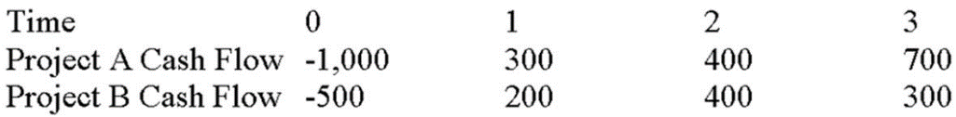
Calculate the payback and use the payback decision rule to evaluate these projects; which one(s) should be accepted or rejected and why?

9. Suppose your firm is considering two mutually exclusive, required projects with the cash flows shown as follows. The required rate of return on projects of both of their risk class is 8 percent, and the maximum allowable payback and discounted payback statistic for the projects are two and three years, respectively.
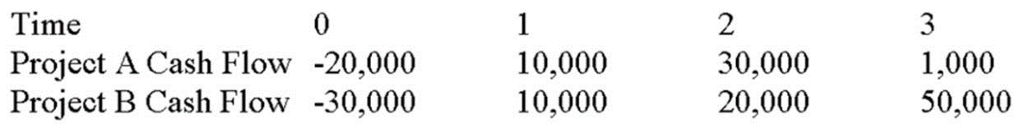
Calculate the NPV and use the NPV decision rule to evaluate these projects; which one(s) should be accepted or rejected and why?

10. Suppose your firm is considering investing in a project with the cash flows shown as follows, that the required rate of return on projects of this risk class is 8 percent, and that the maximum allowable payback and discounted payback statistics for the project are three and a half four and a half years, respectively. Use the payback decision to evaluate this project; should it be accepted or rejected? What is the payback period?
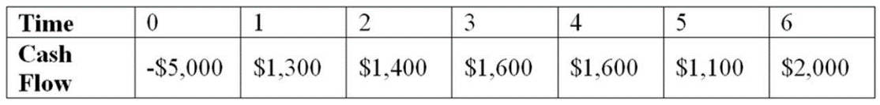
11. A. What is the firms breakeven point in units?
B. Draw a breakeven chart for this firm.

FC = 20
P = 2
VC = .80
11.

.

